Virtual Clinic


January 15 -16, 2026
Connect with Confidence
YouNetResuIts.com / 678-910-1401
brian.gillis@younetresults.com


Required Required Preferred

Opening Thoughts


Advisor Results Academy (ARA)
Presenting

Virtual Clinic
Feature
Results-Learning that Grows Your Confidence
This is not a lecture or a speech, it’s a clinic. A hands-on, participation by all, voice, mind and body. Old habits are hard to break, new ones are hard to learn, and sometimes we don't want to do either.

ARA believes you must learn it, use it, teach it and own it. That's our goal for our time together.

In our business we only have two ways to improve sales, increased car count or making the cars count!! It’s proven that great communication skills will impact both your car count as well as your ARO. Let’s explore how you can maximize your communication skills and connect with confidence.
Let’s Get Acquainted

- Name: ____________________________________________________________________

- Shop Name: _______________________________________________________________

- Location: ____________________________________________________________________________________________________________________________________________________________________________________________________________________

- How long have you been in the automotive industry? _____________________________

- What do you like most about what you do? _____________________________________

PARP

Prepare - Audit - Rehears - Present

Accountability and Performance Checklist

Prepare
Audit
Rehearse

Why & How – Phone Skills
Four Reasons

- ______________________________________________________________________________________________________________________________________________________
- ______________________________________________________________________________________________________________________________________________________
- ______________________________________________________________________________________________________________________________________________________
- ______________________________________________________________________________________________________________________________________________________

Eight Rules to Phone Skills
- ______________________________________________________________________________________________________________________________________________________
- ______________________________________________________________________________________________________________________________________________________
- ______________________________________________________________________________________________________________________________________________________
- ______________________________________________________________________________________________________________________________________________________
- ______________________________________________________________________________________________________________________________________________________
- ______________________________________________________________________________________________________________________________________________________
- ______________________________________________________________________________________________________________________________________________________
- ______________________________________________________________________________________________________________________________________________________

Voice Inflection



Jeff called in sick today…
Jeff called in sick today…
Jeff called in sick today…

Mr. Smith scheduled his car in….

Jeff called in sick today…
Jeff called in sick today…
Jeff called in sick today…

So this is what we’re working with
…

So this is what we’re working with

So this is what we’re working with

So this is what we’re working with

So this is what we’re working with

So this is what we’re working with

Top Three Incoming Calls

O: ___________________________________________________________________________
____________________________________________________________________________________________________________________________________________________________

I: ____________________________________________________________________________
____________________________________________________________________________________________________________________________________________________________

P: ___________________________________________________________________________
____________________________________________________________________________________________________________________________________________________________

- What is the number one offer that auto repair shops advertise to their customers? _________________________________________________________________________________________________________________________________________________________________________________________________________________________________

- Why is this the number one way of advertising? _________________________________________________________________________________________________________________________________________________________________________________________________________________________________

- What can you do to be prepared for the top three calls? _________________________________________________________________________________________________________________________________________________________________________________________________________________________________

- Why do we have the “Home Field Advantage”? ________________________________________________________________________________________________________________________________________________________________________________________________________________________________

The Tie-Down: Capturing the Car

________________________________________________________________________________________________________________________________________________________________________________________________________________________________________________________________________________________________________________________________________________________________________________________________________________________________________________________________________________________________________________________________________________________________________________________________________________________________________________________________________________________________________________________________________________________________________________________________________________________________________________________________________________________________________________________________________________________________________________________________________________________________________________________________________________________________________________________________________________________________________________________________________________________________________________________________________________________________________________________________________________________________________________________________________________

The Incoming Phone Call - Oil Change Script

How much do you charge for an oil change?

Sure, may I get some information from you?

Yes

What is the year and make model of your vehicle?

Do you prefer full synthetic oil or a blend?

The oil change service for your vehicle will run $__________, and that includes all taxes and fees.

That includes a new oil filter, as well as a multi-point courtesy inspection performed by one of our ASE Certified technicians ...... IS NOW A GOOD TIME to bring in your vehicle?

**When would be a good time to bring in your vehicle?
**Is now a good time to drop off your vehicle?

THEN ...Tie it down

1. name
2. best phone #
3. Verify location, use land marker if possible
4. Confirm date and time
5. My name is _____ just ask for me when you come in and we will get you taken care of.

The Packaged Priced Oil Change Script

How much do you charge for an oil change?
We have a great special on our oil change service, it runs $69.95 plus the sales tax and includes up to 5 quarts of (BRAND) or (PREMIUM) full synthetic motor oil, a
new (BRAND) oil filter, as well as a digital vehicle inspection performed by one of our ASE certified technicians.

Is now a good time to bring in your vehicle?

When would be a good time to schedule in your vehicle?

Is now a good time to drop off your vehicle?

YES, I can bring the vehicle in today at 2pm.

Excellent, let me just get some information from you….

THEN …Tie it down.
1. name
2. best phone #
3. Verify location, use land marker if possible
4. Confirm date and time
5. My name is _____ just ask for me when you come in and we will get you taken care of.

The Quick Close
Do you, Can you....

ABSOLUTLEY.... Is now a good time to bring in your vehicle?

**When would be a good time to bring in your vehicle?
**Is now a good time to drop off your vehicle?

Then Tie it down
GREAT!

1. name
2. best phone #
3. Verify location, use land marker if possible
4. Confirm date and time
5. My name is _____ just ask for me when you come in and we will get you taken care of.

Anytime Script

Ringing Thank you for calling anywhere automotive.

Yes, could you tell me how much you would charge me for a front brake job?

What type of conditions are you experiencing with you brakes?

I hear some squeaking and grinding when I come to a stop.

ANYTIME you are experiencing _________________ you need to have

That inspected by one of our ASE certified trained technicians......

At no charge to you, we will provide you with a complete written estimate.

Is now a good time to bring in your vehicle?

**When would be a good time to bring in your vehicle?
**Is now a good time to drop off your vehicle?

Then Tie it down
GREAT!
1. name
2. best phone #
3. Verify location, use land marker if possible
4. Confirm date and time
5. My name is _____ just ask for me when you come in and we will get you taken care of.
Notes Page
________________________________________________________________________________________________________________________________________________________________________________________________________________________________________________________________________________________________________________________________________________________________________________________________________________________________________________________________________________________________________________________________________________________________________________________________________________________________________________________________________________________________________________________________________________________________________________________________________________________________________________________________________________________________________________________________________________________________________________________________________________________________________________________________________________________________________________________________________________________________________________________________________________________________________________________________________________________________________________________________________________________________________________________________________________________________________________________________________________________________________________________________________________________________________________________________________________________________________________________________________________________________________________________________________________________________________________________________________________________________________________________________________________________________________________________________________________________________________________________________________________________________________________________________________________________________________________________________________________________________________________________________________________________________________________________________________________________________________________________________________________________________________________________________________________________________________________________________________________________________________________________________________________________________________________________________________________________________________________________________________________________________________________________________________________________________________________________________________________________________

Full System Isolate (Initial Concern) Presentation Script

Mr./Mrs. _____________ this is ____________ from _____________ is now a good time
(Customers Name) (Your name) (Shop Name)
to talk? If the answer is “No”…responding with…When is a Good time to call you back?

If the answer is “Yes”…respond with …Great!

My ASE technician _______________ and I have personally inspected _____________
(F&B) (Tech’s first name) (Credibility) (Mirror back concern as the customer stated)

And have taken digital photo graphs and or a video for your records as well.

Over all the _________________ is in Great Shape. (If it truly is)
(System being addressed only)

List Three Positive of The Particular System We are Addressing:
(All for reassurances)

The ___________________ is in ________shape, (choose the proper wordage, normal,
(Insert word) excellent, not leaking, good, great,
condition, satisfactory)
The ___________________ is in ________shape, (Blend in with failure explanation)
(Insert word)

The ___________________ is in ________shape,
(Insert word)
We have isolated your concern and identified these items needing immediate attention (Deliver with Urgency and Conviction!) Be prepared to explain functionality of fail component(s), along with ECM.

Failure _____________________________________________________________________
Effect ______________________________________________________________________
Cause ______________________________________________________________________
Maintenance _________________________________________________________________

Again, overall the __________________________ is in Great Shape! (Reassurance)
(System being addressed)
Your total investment for this repair is $ ______________ dollars (include all taxes and ad on fees),

This repair has a _____ year - _____ miles Nationwide Guarantee. (Or insert Guarantee this repair has)
(F & B and Reassurance)
So, with your permission I’ll have __________________________ get started on the repairs.
(Do not pause keep pushing through) (Insert tech’s first name)
Is this a good number to reach you periodically throughout the day with update ____ (wait for the answer)

Once the repair is completed and your vehicle is road tested. I’ll have _______ to perform a complimentary maintenance inspection, to make sure the rest of the vehicle is in safe and operating order. (This can be delivered during an update or with the Isolation presentation)

Thank you – I will be talking with you soon. (Always assume the customer wants it fixed!!!

PREVENTIVE MAINTENANCE INSPECTION

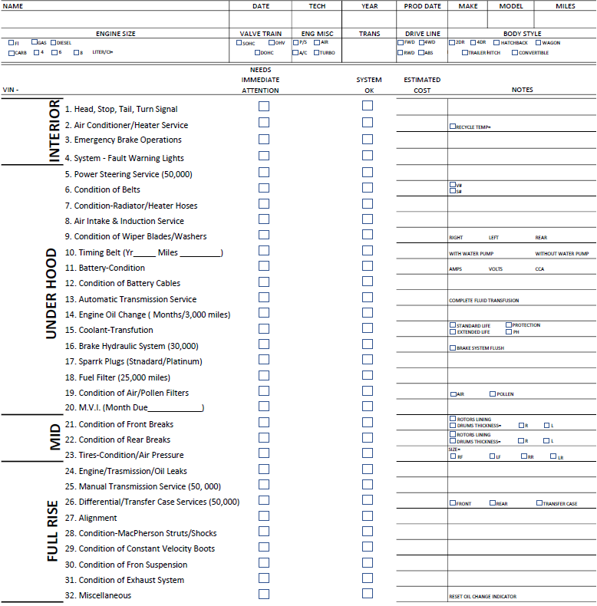

PMI (Additional Concerns) Presentation Script

Mr. / Mrs._____________________ this is ____________ from ______________ is now a good
(Insert customers name) (Your Name) (Insert Shop Name)
time to talk? If the answer is "No"... responding with... When is a good time to call you back?
If the answer is "yes". . . respond with. . . Great!

The repairs on your ____________ have been completed and we don't see any other
issues with this repair at this time! (Make sure nothing else is needed before you proceed)

As promised my ASE Technician __________________ and I have personally completed the
Preventive Maintenance Inspection on your vehicle and have taken digital photographs of your vehicle. Overall, your vehicle is in great shape (if it truly it is).

First: We started with the test drive and under-hood inspection.

We have inspected _______________________ and it was in great shape.
We have inspected _______________________ and looks like it was recently replaced.
We have identified your _______________________ is due by milage.
We have inspected _______________________ and it was in great shape.
We have identified your _______________________ are bad and they need to be replaced.
We're also going to_______________________ and _____________________________.

Additional Notes: ______________________________________________________
______________________________________________________________________________

Second: We performed a mid-rise inspection and identified the following:
We have inspected _______________________ and it looks good.
We have inspected _______________________ and they have ___ /32nds of tread.
We have identified your _______________________ are worn out and they need to be monitored.
We have inspected _______________________ and it was in great shape.
We have identified your ________________________are bad and they need to be replaced.
We're also going to_______________________ and _____________________________.

Additional Notes: ______________________________________________________
___________________________________________________________________

Third: We completed the full rise inspection and identified the following:
We have inspected _______________________ and it was in satisfactory shape.
We have inspected _______________________ and it was in great shape.
We have identified your _______________________ are bad and they need your immediate attention.
We have inspected _______________________ and it is free of leaks.
We have identified your _______________________ are bad and they need to be replaced.
We're also going to_______________________ and _____________________________.

Additional Notes: ______________________________________________________
___________________________________________________________________

Overall, your _______________________ is in Fine Shape!
(Insert vehicle Type)

These additional repairs also have the _________ month – __________ miles Nationwide guarantee.

Your additional investment today is $ ____________ dollars which brings your total investment to $ ___________ and this includes all taxes and fees.

Again, your vehicle is well worth the investment (if it is), so with your permission I will have
___________________ started on the additional repairs. (Do not pause keep pushing through)

Is this still the best number to reach you?

Great, I'll give you a call once your vehicle has been road tested and completed.

Additional Notes: _______________________________________________________________
____________________________________________________________________________________________________________________________________________________________

Gut-Punch / Practice:
Step 1: Understand the comment and concerns

If the customer declines a repair, we need to understand why.

May I ask you an interesting question? (Pause for answer)

Is there a particular reason why we can’t get these repairs addressed for you today? (Repeat back what they said word for word) (LISTEN) ... slow down...dig in and find out what the comments or concerns really are...gain clarity!)

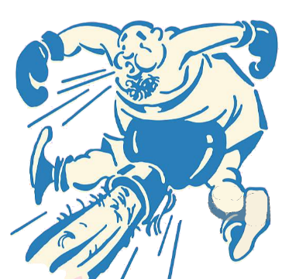
MINDSET: Remove yourself mentally from the conversation, remove the presentation hat, relax, pushback, lay down your pen, close the binder, slow it down, give the customer time to think, turnover the presentation sheet and write on the back. Shift into mindset. Move the energy to finding the solution by exploring options. Listening to the customer's comments will help you transition from Gut Punch, it's okay for the customer to say no or yes, they are equal, let's partner with the customer to find what is best for them. Remember, people don't care how much you know, they want to know you care. Listen for the issue, then use the options that fit the true comment. Don't rush through the script. Slow down and respond. Take the sales hat off and put the listening hat on. Start conversing

Additional Notes: __________________________________________________________________________________________________________________________________________________________________________________________________________________________________________

Step 2...Find the options and solutions
Pause. Rub your chin. Become reflective, speak slowly and state the ASK. (Speak slowly this is a school zone),

Are you open to a couple of options to find a solution so you can get this repair completed? (Pause for a response)

Homefield Advantage




Issues/Concerns

Solutions/Response

Presenting Power - Word Analogies

______________________________________________________________________________________________________________________________________________________

______________________________________________________________________________________________________________________________________________________

______________________________________________________________________________________________________________________________________________________

______________________________________________________________________________________________________________________________________________________

______________________________________________________________________________________________________________________________________________________

______________________________________________________________________________________________________________________________________________________

______________________________________________________________________________________________________________________________________________________

______________________________________________________________________________________________________________________________________________________
Please Share Your Feedback

What did you learn? ____________________________________________________________________
_____________________________________________________________________________________
_____________________________________________________________________________________
_____________________________________________________________________________________

What was you’re your biggest takeaway? ____________________________________________________
_____________________________________________________________________________________
_____________________________________________________________________________________
_____________________________________________________________________________________

What was your largest “aha” moment? ______________________________________________________
_____________________________________________________________________________________
_____________________________________________________________________________________
_____________________________________________________________________________________

What will you take back and use during your next work day? ____________________________________
_____________________________________________________________________________________
_____________________________________________________________________________________
_____________________________________________________________________________________

If there was one thing you would change to make the ARA Front Counter Workshop experience better
for you, what would it be? _______________________________________________________________
_____________________________________________________________________________________
_____________________________________________________________________________________
_____________________________________________________________________________________

For fresh new content, please subscribe to my channel and follow me on Facebook !
Search You Net Results.
Please Share Your Feedback

What did you learn? ____________________________________________________________________
_____________________________________________________________________________________
_____________________________________________________________________________________
_____________________________________________________________________________________

What was you’re your biggest takeaway? ____________________________________________________
_____________________________________________________________________________________
_____________________________________________________________________________________
_____________________________________________________________________________________

What was your largest “aha” moment? ______________________________________________________
_____________________________________________________________________________________
_____________________________________________________________________________________
_____________________________________________________________________________________

What will you take back and use during your next work day? ____________________________________
_____________________________________________________________________________________
_____________________________________________________________________________________
_____________________________________________________________________________________

If there was one thing you would change to make the ARA Front Counter Workshop experience better
for you, what would it be? _______________________________________________________________
_____________________________________________________________________________________
_____________________________________________________________________________________
_____________________________________________________________________________________

For fresh new content, please subscribe to my channel and follow me on Facebook !
Search You Net Results.

